CASSOFT SOFTWARE DESCRIPTION

**Background:**

In our quest as developers to contribute to society, a team of Ashesi students embarked on a journey to underdeveloped communities in Ghana. We found ourselves in Ankonam- Oyarifa where we got to experience first-hand the plight of school administrators of some private schools in the area. Typical of them was Christ Ambassadors School. Our mission was to provide a technological solution to their problem.

* Because of the financial challenges parents pay school fees by day or when it becomes available. This made tracking payments and managing finances an exhausting tasks.
* There were always quarrels by parents who claimed to have paid and due to the schools inability to show concrete proof scuffles were a common occurrence.
* Finally at the end of the term making a financial report of spending total school fees collected was almost impossible.

**Scope and Purpose:**

**CASSOFT is a Java based application that allows school admins to manage fee payment in an efficient way. It makes the process of financial management a simple clicking process. CASSOFT was built mainly to help schools in rural areas in Ghana to ease the burden of resource management.**

**Methods and Instrumentation:**

Technologies used are Java, JavaFX, JDBC and mySql. User Interface was custom designed with adobe illustrator and incorporated into JFrame.

**Limitations, Questions and Issues:**

CASSOFT was built with JDBC employing mySql and therefore computers that run CASSOFT must have mySql server running to be able to allow persistence from a database.

An sql file containing cassoft must be run on the parent pc in order to create the database.

Build Instructions

The Project files contains:

A JAR file that allows the program to be run as a standalone application.

* Project files
* A cassoft.sql file with dump
* A dist folder for a standalone jar file
* Snapshots
* Documentation
* An CASSOFT SOFTWARE DESCRIPTION pdf file

For Purposes of Running Cassoft mySql server needs to be turned on throughout.

1. Turn on your mySql server and run the cassoft.sql file. This will create a database called cassoft with some information dump.
2. 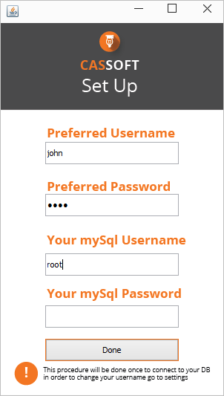Run the cassoft-version2.jar file if you want to run as a standalone application. Or open the project in NetBeans and run from NetBeans.After running the cassoft-version2.jar for the first time, a window like this will appear.
3. This window allows you to save a preferred username and password which you will use to login into the application normally, also you are required to add your MySQL username and password. This allows us to connect to your database for persistence. If your MySQL does not have a password just leave it blank like in the example. This is a onetime process.
4. This process creates a file called credentials.txt this file is not to be tampered with as it can prevent login. In order to repeat the Set-Up process delete the credentials.txt file
5. You can now login with the username and password you specified initially, not the MySQL password and username. If you forget your username and password use

username: johndoe password:cassoft

# The Application

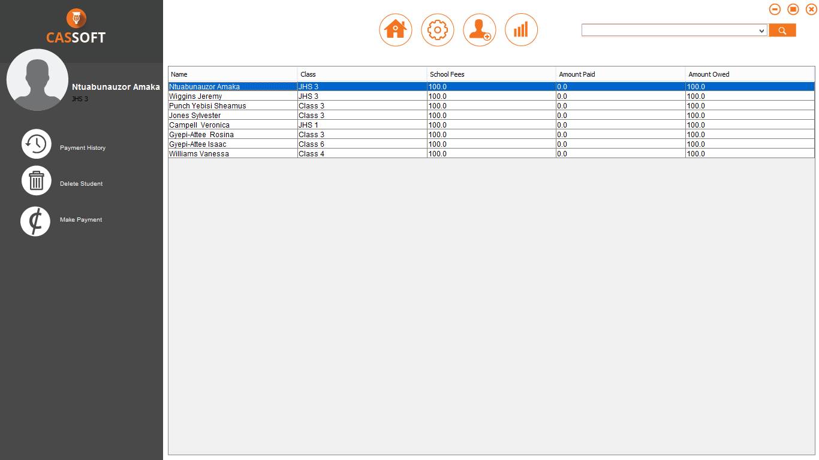

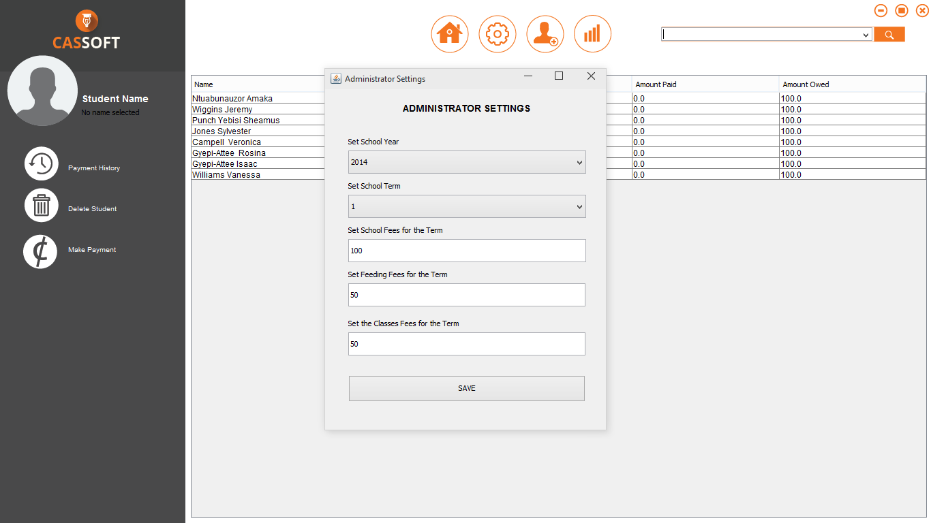

The main functioning features of this application are:

* Selecting a student from the table, which appears in the side bar
* Viewing the payment history of the Student
* Deleting a student
* Making a Transaction
* Switching between Full screen and Maximized
* Settings for administrator
* Login Screen
* A search bar with auto suggest